IT2020 – Software Engineering

**Year 2, Semester II, 2022 Group Assignment**



**Online Hotel Reservation System**

**Group Details**

**Batch: 8**

**SE/OOP Group Number: SE/OOP/2024/S2/KND/WD/G8**

|  |  |  |
| --- | --- | --- |
|  | **Student Registration Number** | **Student Name** |
| **1** | **IT23187078** | **AMAN MOHAMED M. A** |
| **2** | **IT23289048** | **SUHAIL M.S.M** |
| **3** | **IT23386822** | **RAMZY M.H.M** |
| **4** | **IT23357358** | **Ahamed M.S. S** |

Introduction

We are glad to introduce you to “HotelStay”, a fresh idea that has turned the hotel book-and-stay market upside down making it easier for people on the move. There are four different categories of users for “HotelStay”: unregistered users, guests, hotel owners, and administrators of the system.

Unregistered users can access the hotel section, look for any available hotels and check all necessary information without signing in. Guests wishing to make a reservation on the site can register in a few clicks to get practical services they need.

Once registered, guests use their credentials when logging in offline which is checked by the system for security purposed. The system does not stop at this; if users enter wrong or unknown credentials, they are to enter the details all over again. For those who cannot recall the password entered before, a password recovery screen has been built into the system.When guests want to book a hotel room, they can just fill in the place they want to go to, the check-in date, the check-out date, and the type of accommodation they wish for. They will see details of the booking and decide on whether to proceed after the system has determined the amount due for the booking as per the summation of the room rates. Room requests, extra facilities, or services, if any can be also entered at this stage of easy booking.

Credit/debit cards and cash payments are among the convenient methods of payment accepted by “HotelStay” that guests can choose from. They may enter their details once and then save them for easy use at the time of their next and any additional bookings, thus, helping speed up the process of payments. Owners of the hotels can handle their properties through the hotel management system by including or excluding the availability of the rooms, increasing or reducing the prices and adding or removing promo to make the customers come. It is also possible to assess the order statistics and customer reviews to make improvements.

System administrators manage and supervise all employees on the system making sure activities flow in a proper manner. They maintain user accounts, answer client wants, and discipline orders in the booking system.

It is said that “HotelStay” provides a hassle-free experience during making hotel reservations with its easy-to-use platform – accurate and timely connection of travelers with hoteliers and vice versa with every user expecting a satisfying experience.



**Contents**

Use Case Diagram 4

IT23289048| Suhail M.S.M 5

Use Case Scenario 5

Sequence Diagrams 8

Communication Diagrams 11

IT23187078 | Aman Mohamed M.A 13

Use Case Scenarios 13

Sequence Diagrams 15

Communication Diagrams 17

IT23386822 | Ramzy M.H.M 19

Use Case Scenario 19

Sequence Diagram 21

Communication Diagram 22

IT23357358 | Ahamed M.S.S . 23

Use Case Scenario 23

Sequence Diagram 25

Communication Diagram 26

Contributions 27

# Use Case Diagram

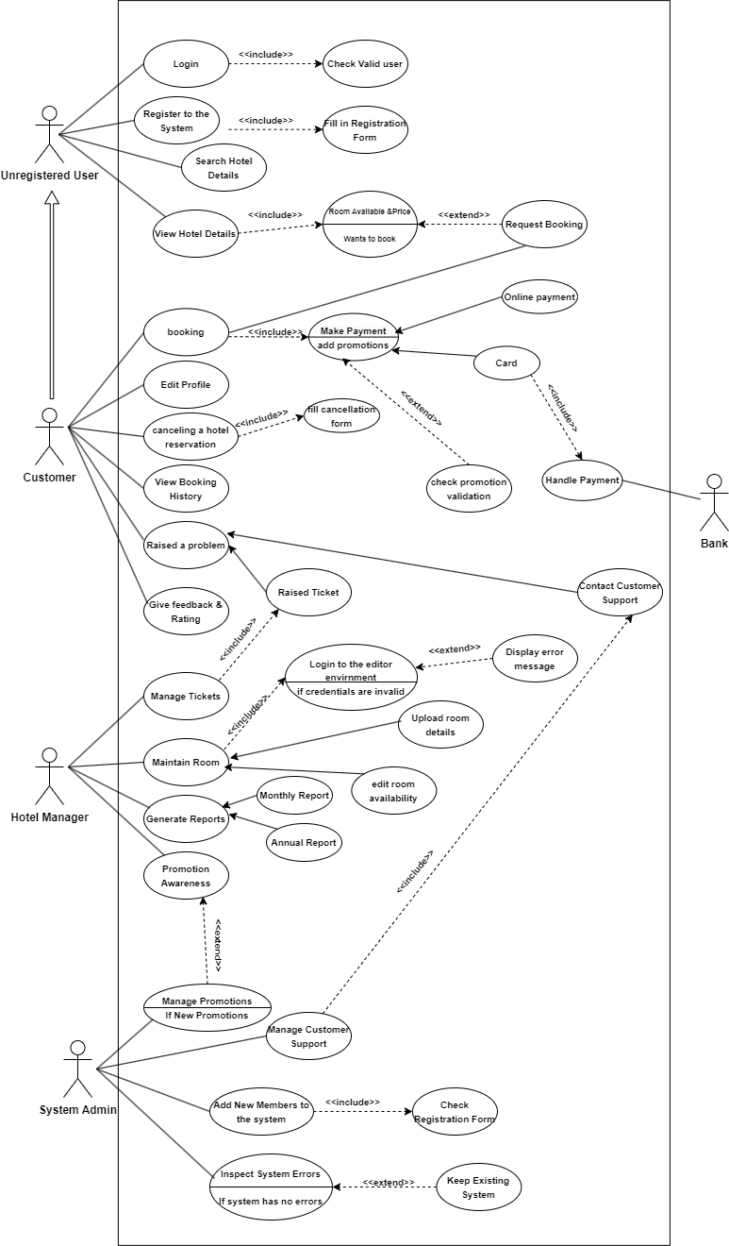

# IT23289048 | Suhail M.S.M

## Use Case Scenario

User login

|  |  |  |
| --- | --- | --- |
| Name | Log In | |
| Summary | registered users log into the hotel reservation system | |
| Priority | 1 | |
| Pre-conditions | The user must be a registered with valid login credentials | |
| Post-conditions | The user is successfully logged into the system | |
| Primary Actors(s) | Registered User | |
| Secondary Actor(s) | - | |
| Main Scenario | **Step** | **Action** |
| 1 | Registered user opens the hotel reservation system and navigates to the login page. |
| 2 | User enters their username and password. |
| 3 | User submits the login request. |
| 4 | System validates the credentials against the stored data. |
| 5 | If valid, the system allows the user access to their account |
| Extensions | **Step** | **Branching action** |
| 2. a | If the user does not enter a username or password, the system prompts them to fill in the required fields. |
| 4. a | If the credentials are invalid, the system displays an error message |
| 4. b | After three unsuccessful login attempts, the system locks the account temporarily. |

Manage user profile

|  |  |  |
| --- | --- | --- |
| Name | Manage User Profile | |
| Summary | Allow the system admin to view, edit, and manage user profiles | |
| Priority | 1 | |
| Pre-conditions | The system admin logged into the system with appropriate admin credentials. | |
| Post-conditions | user profiles are updated successfully and saved in the database. | |
| Primary Actors(s) | System Admin | |
| Main Scenario | **Step** | **Action** |
| 1 | System admin logs into the system using admin credentials. |
| 2 | System verifies the admin's credentials |
| 3 | Admin goes to the User Management section. |
| 4 | Admin searches for or selects a user from the list of registered users |
| 5 | System displays the user’s profile |
| 6 | Admin edits or updates the user profile |
| 7 | Admin submits the updates. |
| 8 | System validates the changes and updates the user profile in the database. |
| 9 | System confirms that the profile has been successfully updated. |
| Extensions | **Step** | **Branching action** |
| 15a | If admin attempts to change restricted fields the system warns about limitations. |
| 16a | If input fields are invalid, the system highlights the errors |
| 17a | If the profile cannot be updated due to a system issue, the system shows error message |

## Sequence Diagrams

User login (Reference)

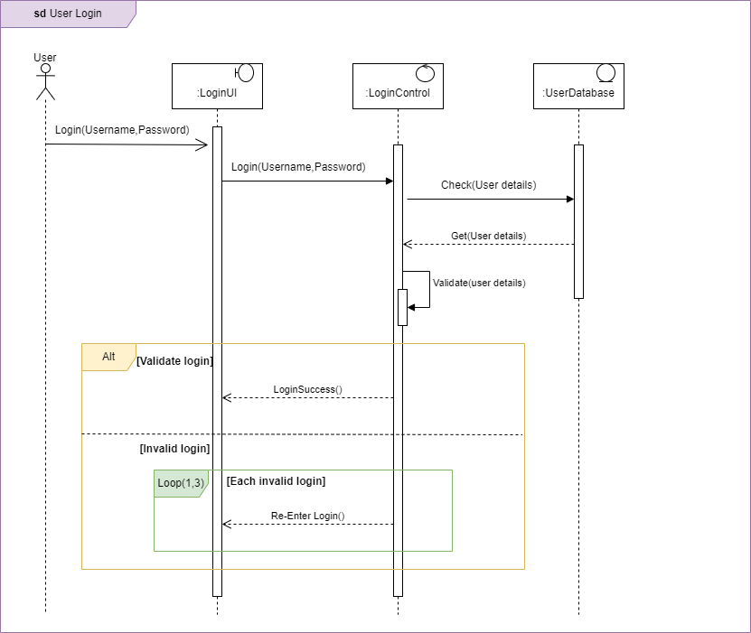

Manage user profile

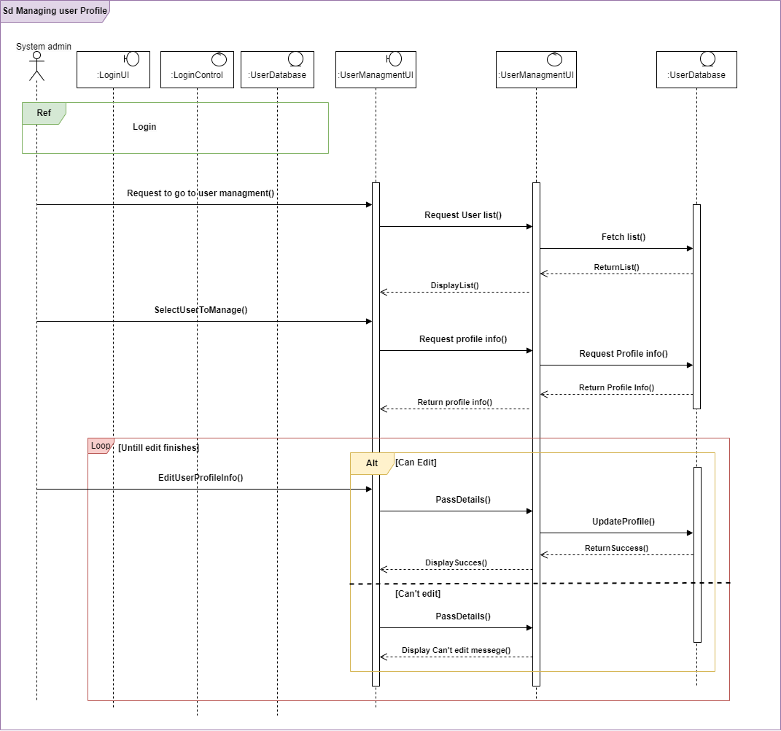

Communication Diagrams

User Login

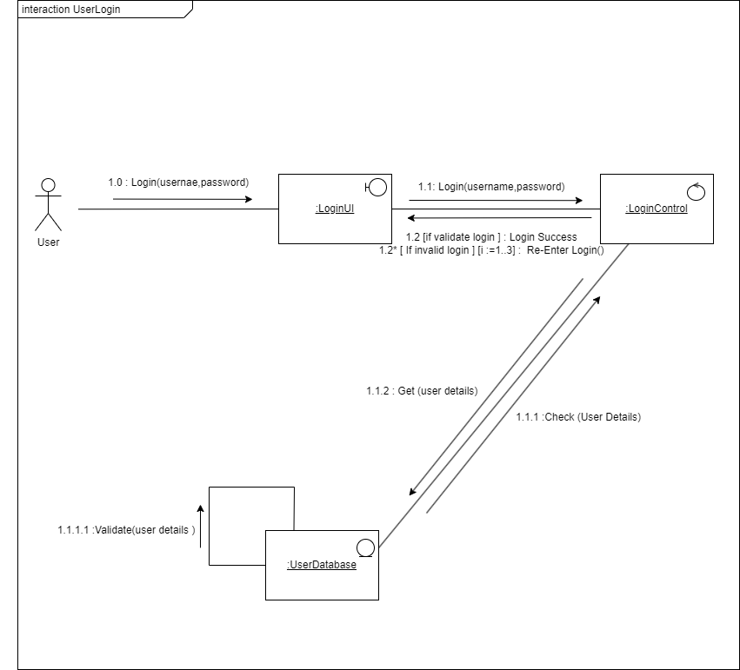

Manage user profile

# IT23187078 | Aman Mohamed M.A

## Use Case Scenarios

Booking

|  |  |  |
| --- | --- | --- |
| Name | Booking | |
| Summary | Allow registered users to book hotel rooms through the reservation system. | |
| Priority | 1 | |
| Pre-conditions | The user must be logged into the hotel reservation system | |
| Post-conditions | Booking is confirmed and stored in the system. | |
| Primary Actors(s) | Registered User | |
| Secondary Actor(s) | - | |
|  | **Step** | **Action** |
| 1 | Registered user logs into the system using their username and password. |
| 2 | System verifies the login credentials. |
| 3 | User selects the "Book a Room" option. |
| 4 | System displays available rooms based on users’ preferences. |
| 5 | User reviews room options and selects a room. |
| 6 | User enters personal details and payment information. |
| 7 | User submits the booking request. |
| 8 | System validates the booking information and processes the payment. |
| 9 | System confirms the booking |
| 10 | User receives a booking confirmation |
| Extensions | **Step** | **Branching action** |
| 4.a | If the rooms not available, the system tells the user to select different option. |
| 6.a | If the user fails system tells to retry |
| 7.a | If payment processing fails, the system tells the user to retry |

Cancel booking reservation.

|  |  |  |
| --- | --- | --- |
| Name | Cancel Reservation | |
| Summary | Allow registered users to cancel their hotel bookings | |
| Priority | 1 | |
| Pre-conditions | The user must be logged into the hotel reservation system and have a booking | |
| Post-conditions | The reservation is successfully canceled | |
| Primary Actors(s) | Registered User | |
| Main Scenario | **Step** | **Action** |
| 1 | Registered user logs into the system using their username and password. |
| 2 | System verifies the login credentials. |
| 3 | User navigates to the booking section |
| 4 | User selects booking they want to cancel. |
| 5 | System displays the booking details and provides an option to cancel the reservation. |
| 6 | User confirms the cancellation. |
| 7 | System processes the cancellation request |
| 8 | System confirms that the reservation has been canceled and updates the database. |
| 9 | System displays the cancellation |
| Extensions | **Step** | **Branching action** |
| 5. a | If the booking is non-cancellable, System notifies the user |
| 6. a | If the user fails to confirm the cancellation, the system keeps the reservation active. |

## Sequence Diagrams

Booking

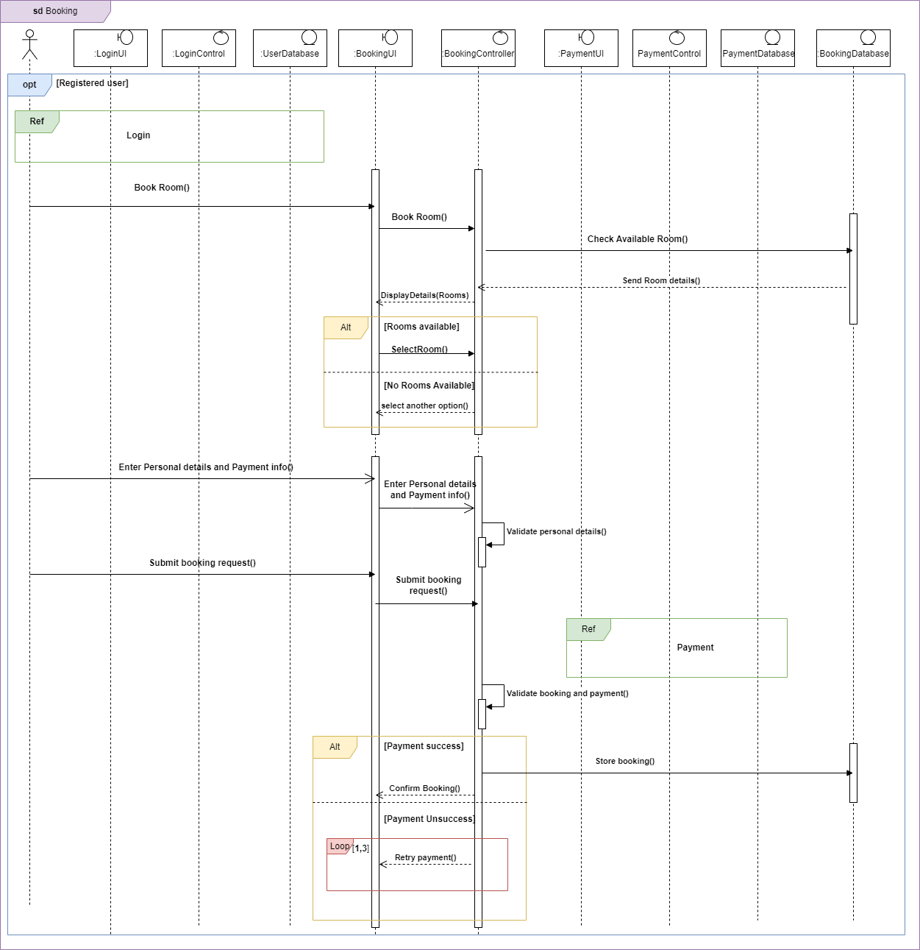

Cancel Booking Reservation

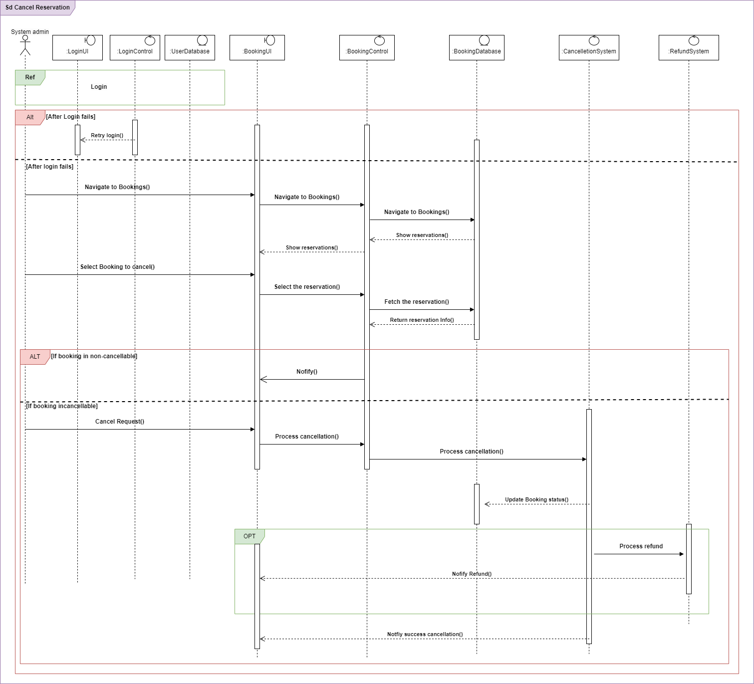

## Communication Diagrams

Booking

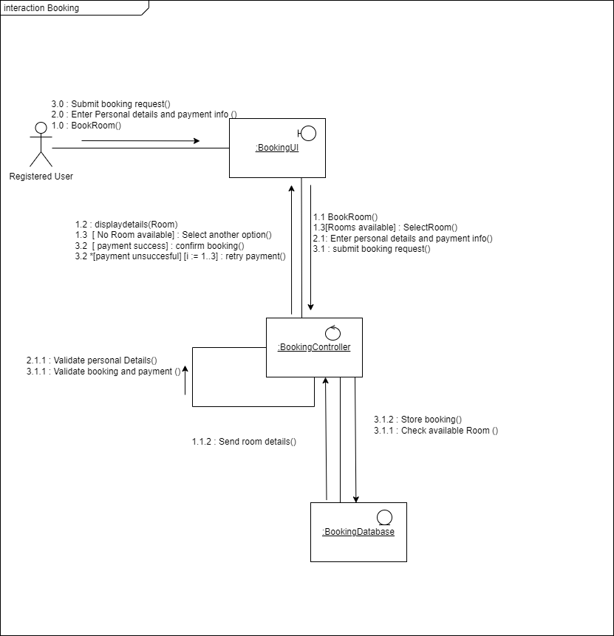

Cancel Booking Reservation

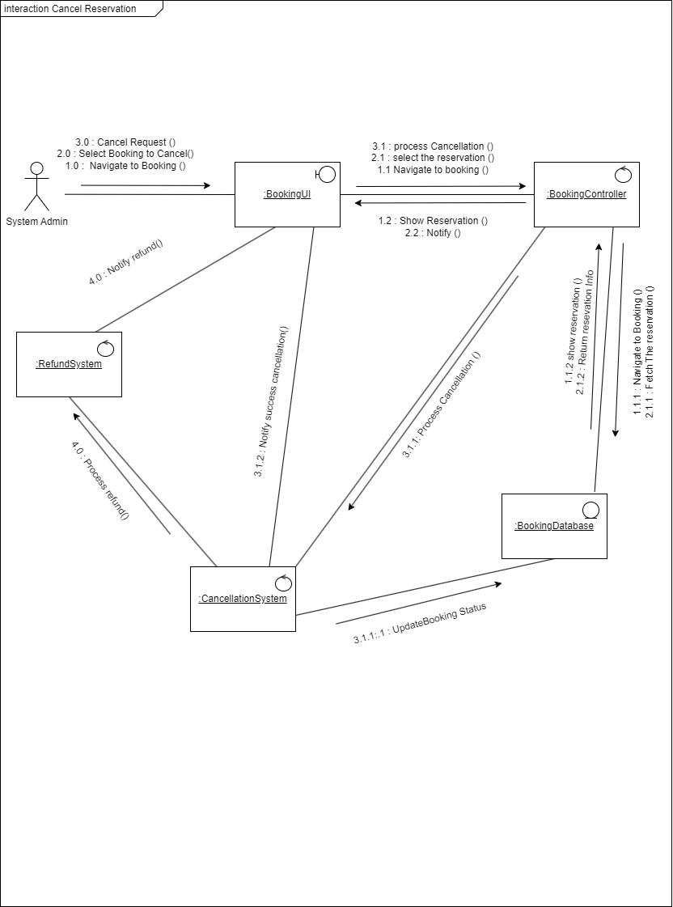

# IT23386822 | Ramzy M.H.M

## Use Case Scenario

Providing Promotion

|  |  |  |
| --- | --- | --- |
| Name | Providing promotion | |
| Summary | Allow the hotel admin (manager) to create and manage promotions for hotel services | |
| Priority | 2 | |
| Pre-conditions | The hotel admin must be logged into the system with appropriate admin details | |
| Post-conditions | Promotion is created and visible to registered and unregistered users.  The promotion is saved in the system | |
| Primary Actors(s) | Hotel Admin (Manager) | |
| Main Scenario | **Step** | **Action** |
| 1 | Hotel admin logs into the system using their admin credentials. |
| 2 | System verifies the admin's credentials |
| 3 | Admin navigates to the "Promotions" |
| 4 | Admin selects the "Create New Promotion" option. |
| 5 | System displays a form where the admin enters promotion details |
| 6 | Admin submits the promotion. |
| 7 | System validates the information |
| 8 | System confirms the promotion and makes it available to users. |
| 9 | Admin receives a confirmation message that the promotion is successful. |
| Extensions | **Step** | **Branching action** |
| 4.a | If there are existing promotions, the admin chooses to edit or delete them. |
| 7.a | If the promotion details are incomplete or invalid it shows a error message |

## Sequence Diagram

Providing promotion

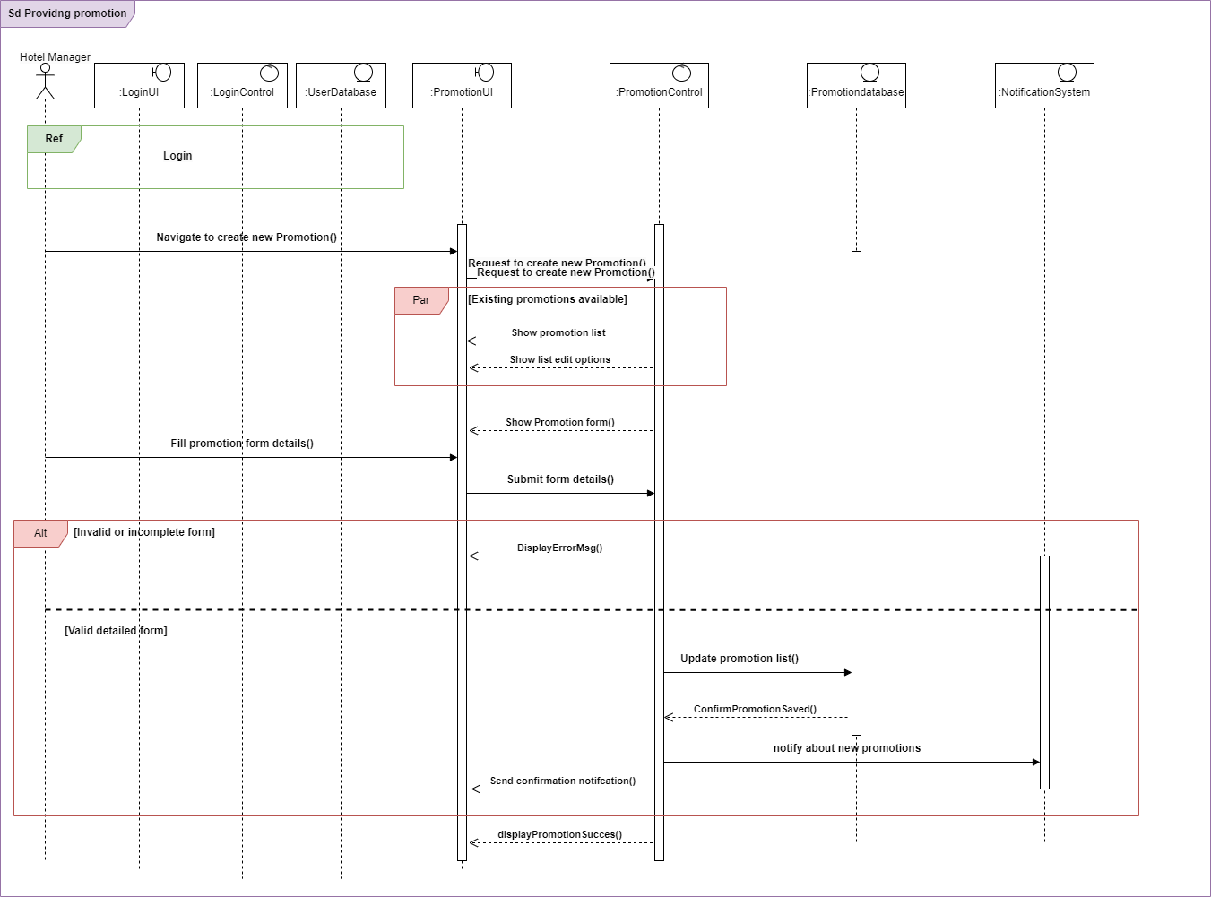

## Communication Diagram

Providing promotion

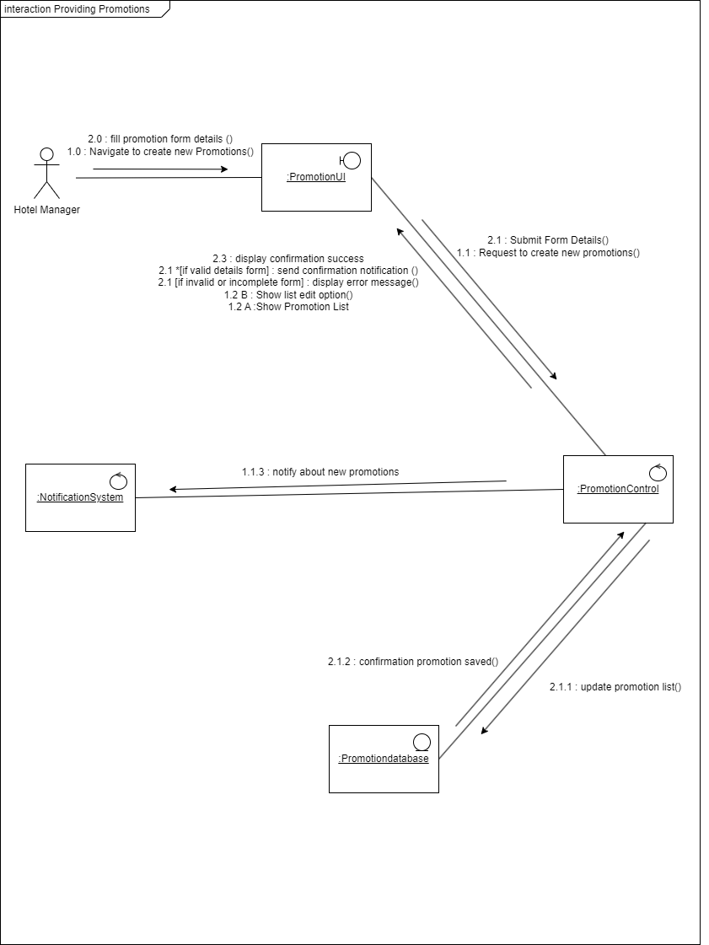

# IT23357358 | Ahamed M.S.S

## Use Case Scenario

Payment

|  |  |  |
| --- | --- | --- |
| Name | Payment | |
| Summary | Allow registered users to make payments for their hotel bookings | |
| Priority | 1 | |
| Pre-conditions | The user must be logged into the hotel reservation system and have a booking | |
| Post-conditions | Payment is processed successfully and confirmed in the system. | |
| Primary Actors(s) | Registered User | |
| Main Scenario | **Step** | **Action** |
| 1 | Registered user logs into the system using their username and password |
| 2 | System verifies the login credentials. |
| 3 | User selects the booking they want to pay for. |
| 4 | System displays the booking details and payment options. |
| 5 | User selects a payment method |
| 6 | User enters payment details and confirms the payment. |
| 7 | System processes the payment and verifies the transaction. |
| 8 | System confirms the payment and updates the booking status. |
| Extensions | **Step** | **Branching action** |
| 6a | If the payment processing fails, the system displays error message |
| 7a | If the payment can't be confirmed the system displays an error message |

## Sequence Diagram

Payment

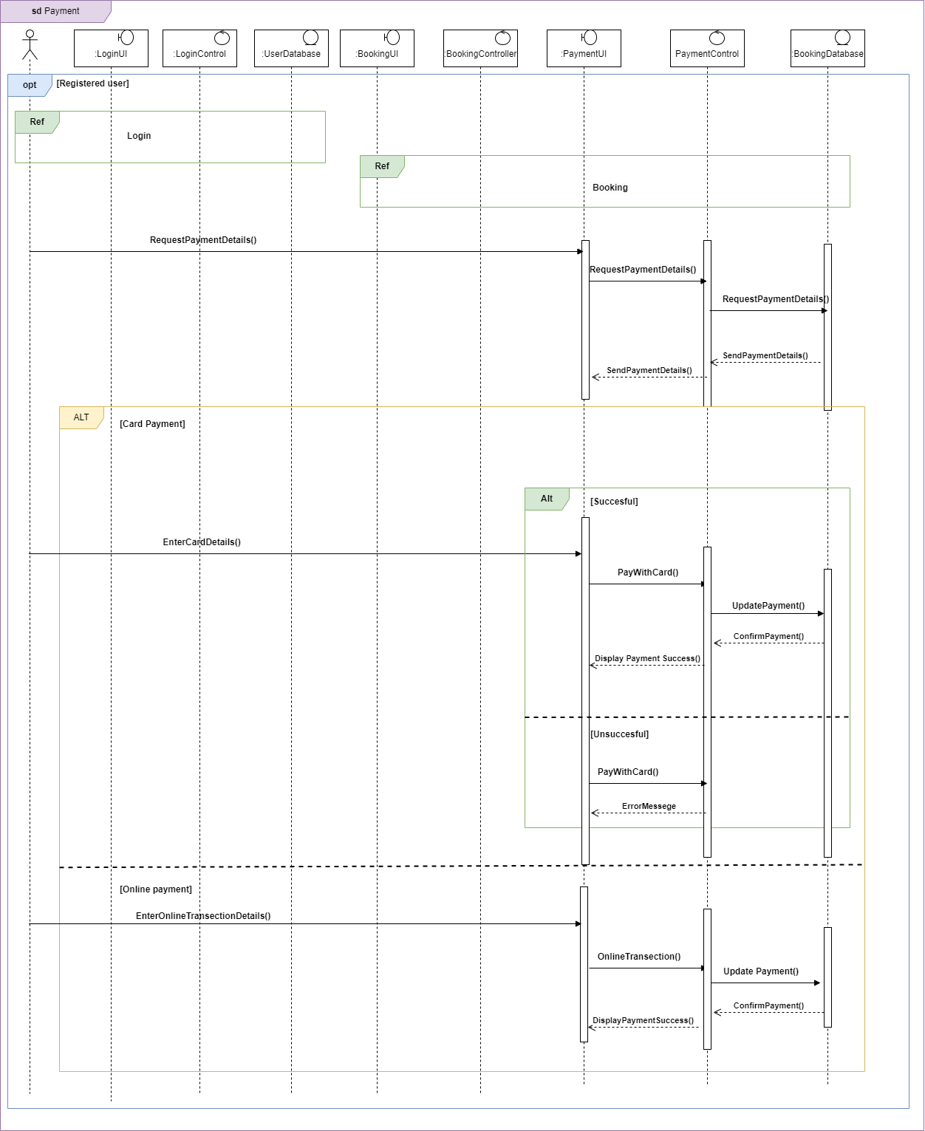

## Communication Diagram

Payment

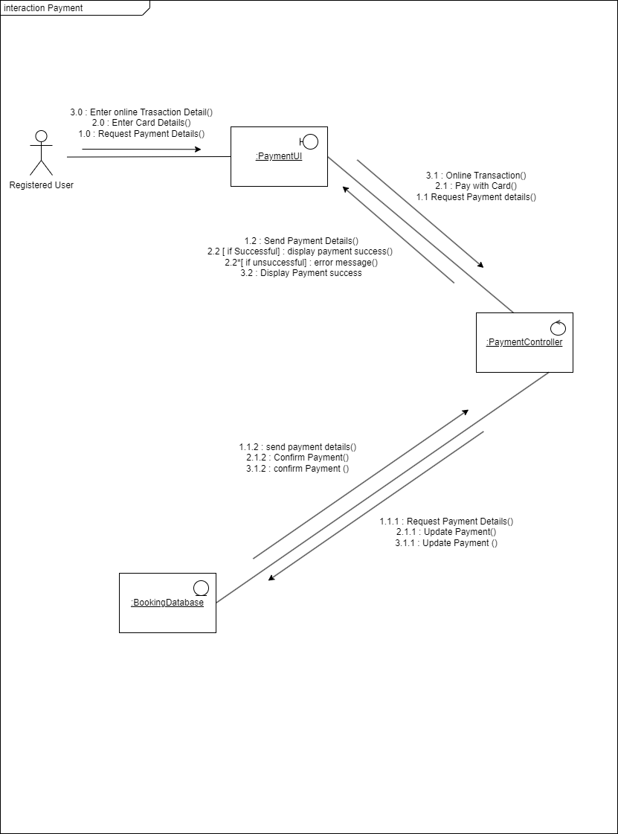

# Contributions

|  |  |  |
| --- | --- | --- |
| Registration No. | Name | Function(s) |
| **IT23289048** | **SUHAIL M.S.M** | * USER LOGIN * MANAGE USER PROFILE |
| **IT23187078** | **AMAN MOHAMED M. A** | * BOOKING * CANCEL RESERVATION |
| **IT23386822** | **RAMZY M.H.M** | * PROVIDE PROMOTION |
| **IT23357358** | **Ahamed M.S. S** | * PAYMENT |